How to Manage A User’s Quarantine Emails

- When receiving an email from ‘reports@serverdata.net’, a user can click on the icon ‘Manage Quarantine Email’ on the bottom of that sent email will re-direct the user to a webpage for ‘Quarantine Area’

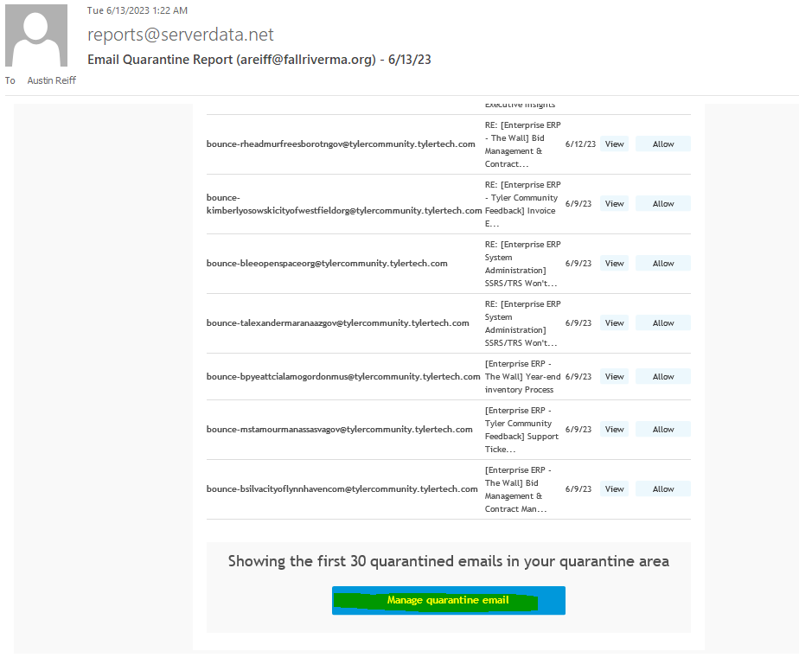

- When on the page for ‘Quarantine Area’ (https://co.quarantine.serverdata.net/) , a user can view all emails that were flagged as apparent ‘phishing’ or ‘spam’ as they did not meet the identification criteria to appear in a user’s regular email inbox
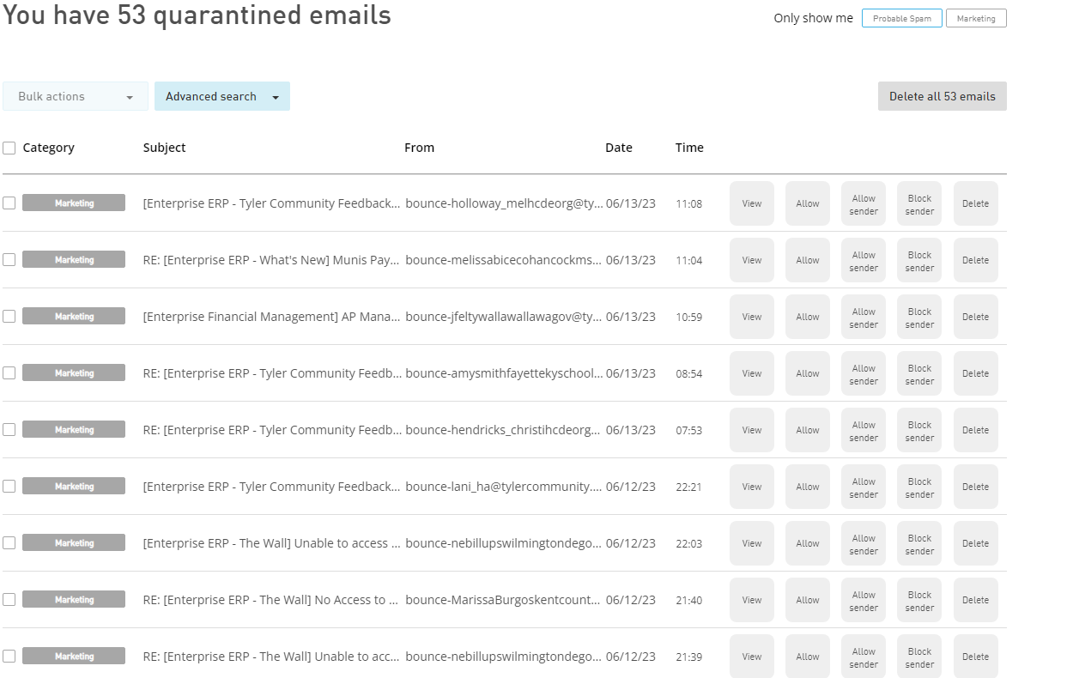

- To view an email, select ‘View’ icon next to that particular email
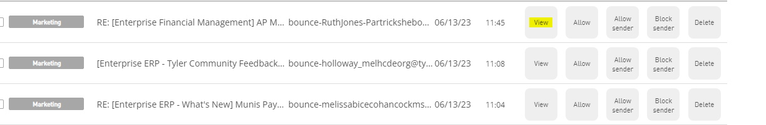

- To push the email through back to a user’s mail inbox, select ‘Allow’ icon next to that particular email
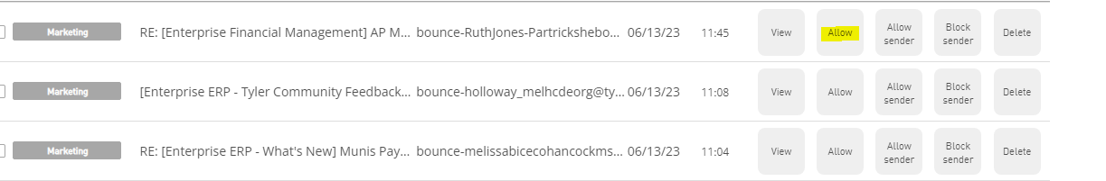
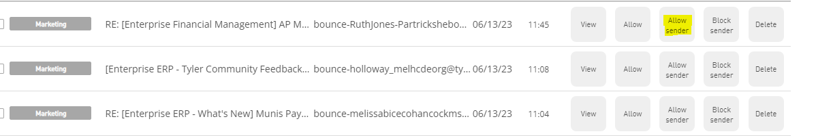
- To always allow that specific sender to send emails directly into a user’s inbox, select the ‘Allow Sender’ icon next to that particular email (make sure the sender is a verified trusted source!)

- To block a specific sender from sending emails to that user (including being flagged in ‘Quarantine Area’), select the ‘Block Sender’ icon next to that particular email
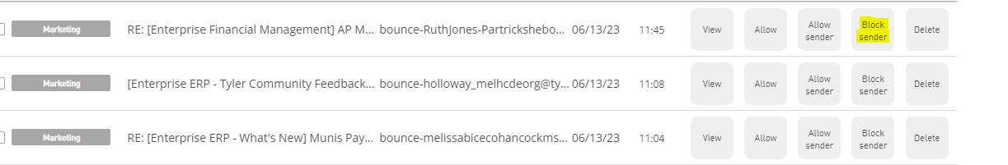

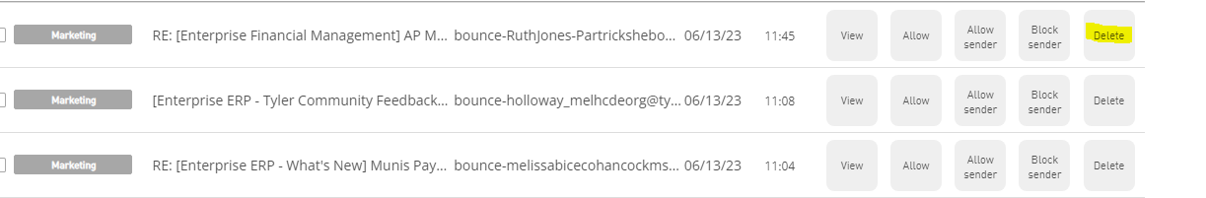
- To delete a single email in a user’s ‘Quarantine Area’, select the ‘Delete’ icon next to that particular email

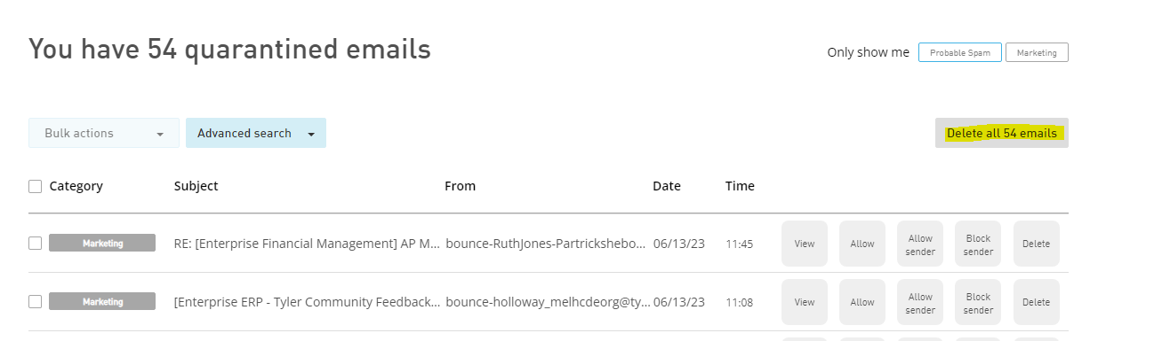
- To delete all existing emails in a user’s ‘Quarantine Area’, select ‘Delete all ____ (number will vary) Emails’ icon on top of page

