How to do an Invoice Entry in MUNIS

- When on MUNIS homepage after logging in, select ‘Enterprise ERP’ then ‘Financials’ then ‘Accounts Payable’ then ‘Invoice Processing’ then select ‘Invoice Entry’
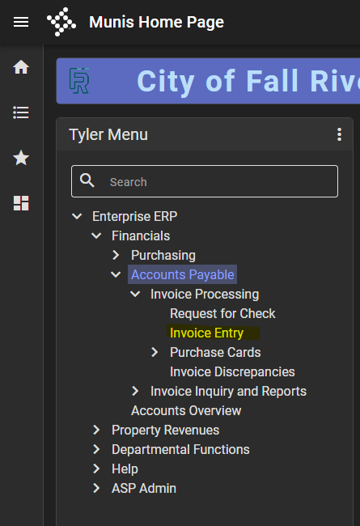

- When on “Invoice Entry” page, select ‘Add Batch’ icon on top of page
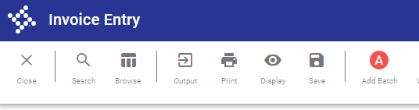
- Write down batch number that appears in ‘Batch’ field, and all other information will auto-populate in fields as well press ‘Accept’
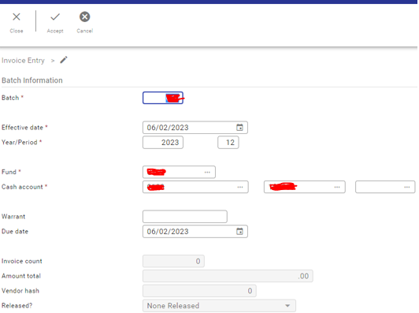

- When back on ‘Invoice Entry’ page, type in ‘PO’ number in ‘PO’ field and the vendor number along with open amount and other information will auto-populate on that page
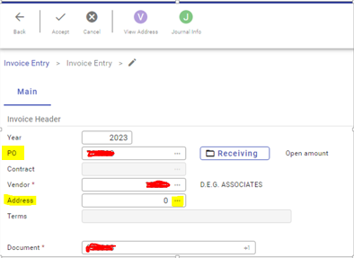
- To find a different address for the vendor, select three dots on side of ‘Address’ box select desired address from list
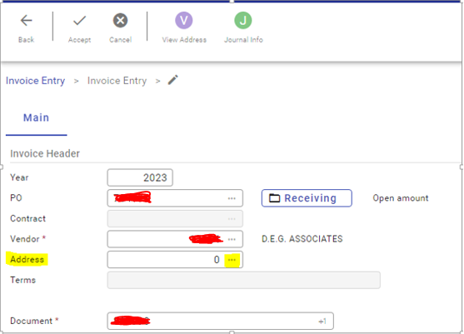
- ‘Tab’ down to ‘Document’ field and the number will auto populate in that box
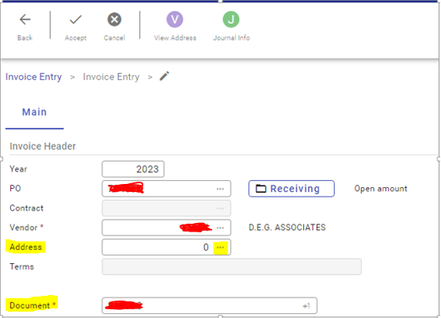

- Then, put invoice number in the ‘Invoice’ box (click three dots to find invoice number if not provided already)
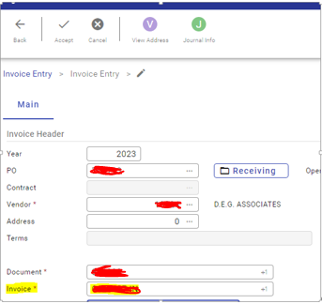
- Type in gross amount in ‘Gross’ box
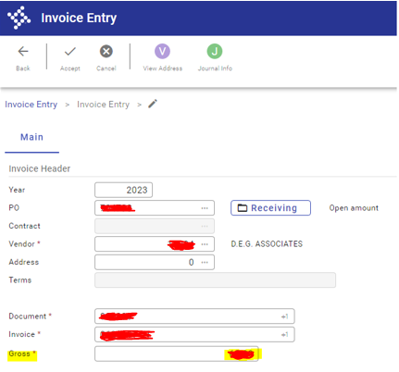

- Keep pressing ‘tab’ key on keyboard after gross amount has been entered a new page for ‘Purchase Order Account Liquidation’ will appear select ‘Modify’ icon on top of page
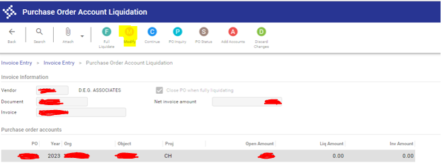
- Enter amount for ‘Liquation Amount’ ‘tab’, then ‘tab’ again make sure information on bottom of page is correct
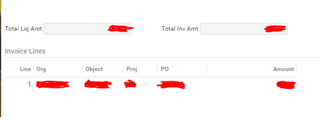

- Select ‘Accept’ icon on top of page to accept changes
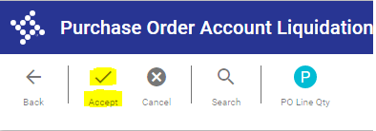

- Select ‘Continue’ icon on top of page
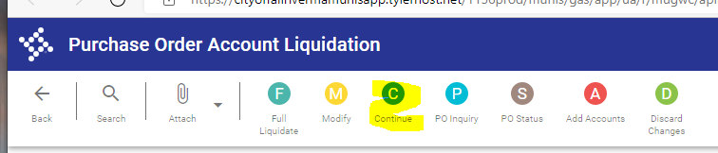

- Select ‘Yes’ when “Liquidation Warning” message appears on screen
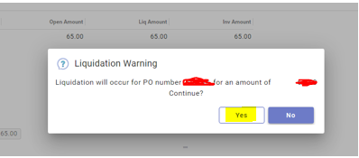
- When returned to ‘Invoice Entry’ page, select ‘Accept’ icon on top of page
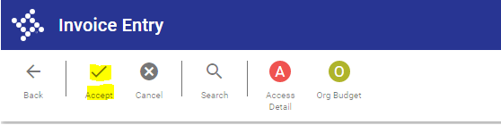

- To add another invoice, select ‘Add’ icon on top of that page.
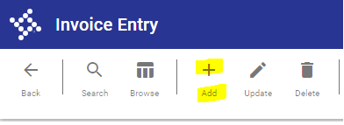

- To add supportive documentation for an invoice, select ‘Attachment’ icon select ‘Create New Document’ icon 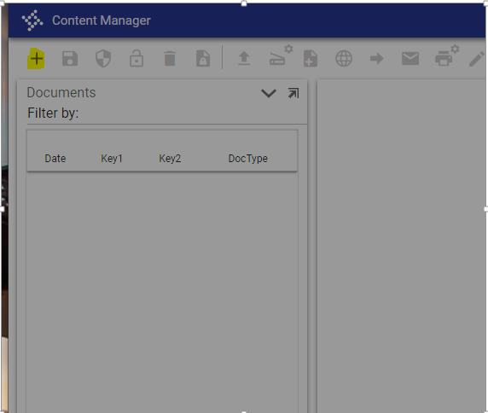

- Select ‘AP Invoice’ from list
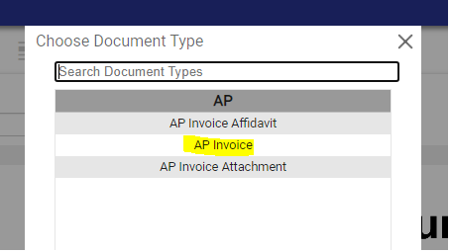

- Then, select ‘AP Invoice’ again from other list
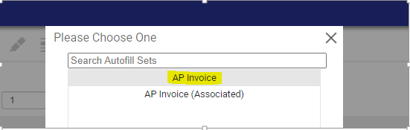

- When it says ‘Import Document’, select ‘choose file’ select file from folder select ‘Import’ to import document
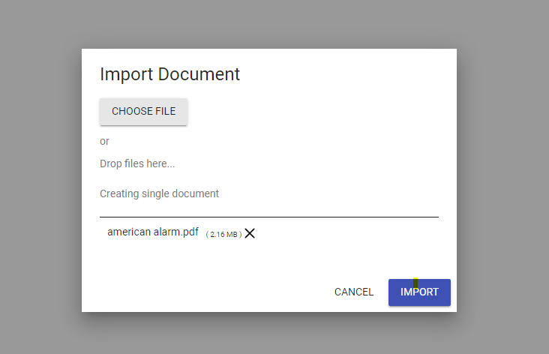
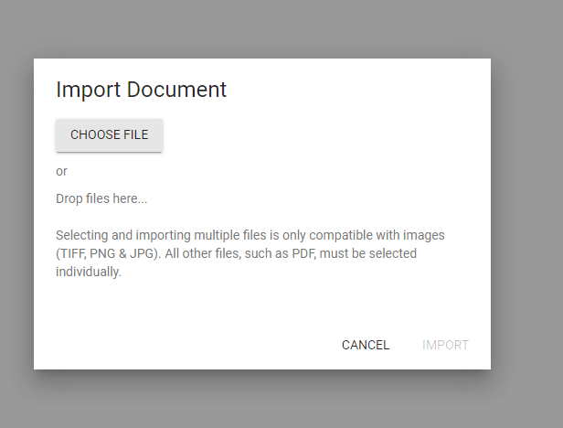

- Select ‘Save Document’ icon on top of page once file has uploaded exit out of “Content Manager”
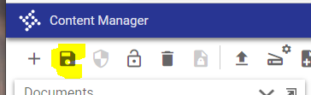

- Select ‘Back’ icon takes user back to ‘Invoice Entry’ page
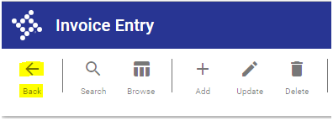

- Click on ‘Sort’ icon on top of page

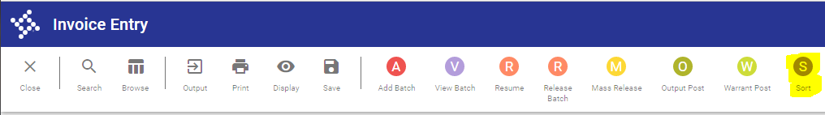
- Always select ‘3 Vednor Alpha’ from list when it appears select ‘Ok’
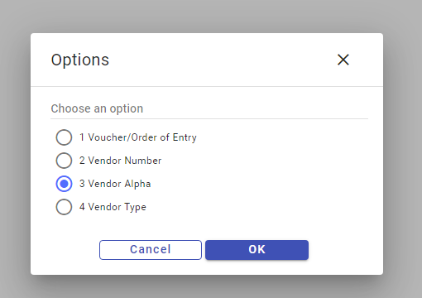

- Select ‘Release Batch’ icon on top of page
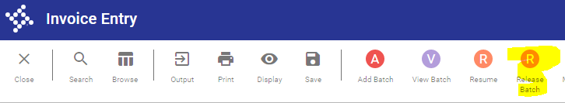

- Select ‘Yes’ when “Post Batch” message appears
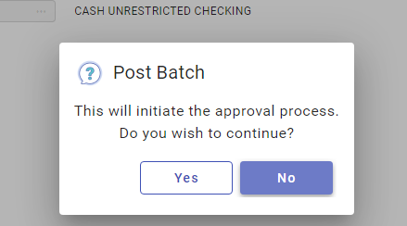

- Select ‘Output’ icon when returned to “Invoice Entry’ page
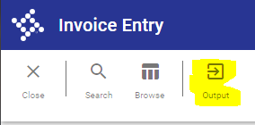

- Only highlighted option should be “Include PO list” press ‘Accept’ icon after
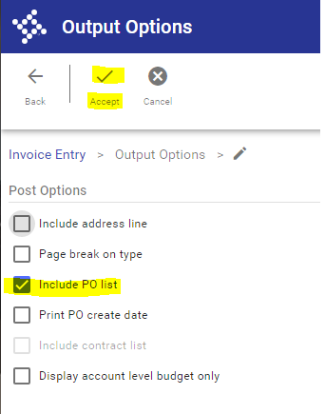
- Pick ‘Display’ option when “Output” screen appears make sure ‘Plain Text’ option is highlighted under ‘Output Style’ select ‘ Ok’
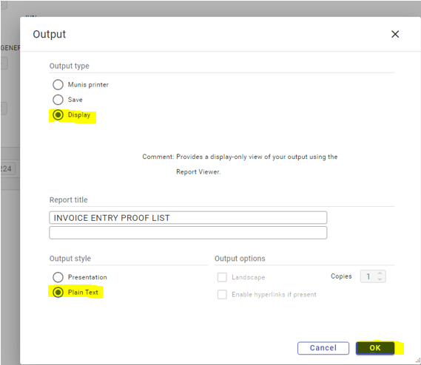

- Select ‘Ok’ when “Some Invoices Are Not Ready To Be Posted” message appears
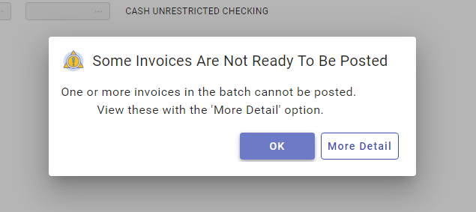

- The report will populate in a separate tab select ‘Print’ icon on top of page to print report out
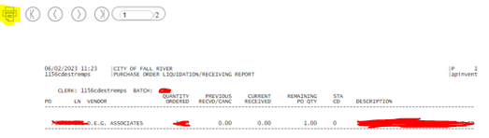

- Check off ‘Landscape’ option under “Layout” select ‘Print on both sides’ select ‘Print’
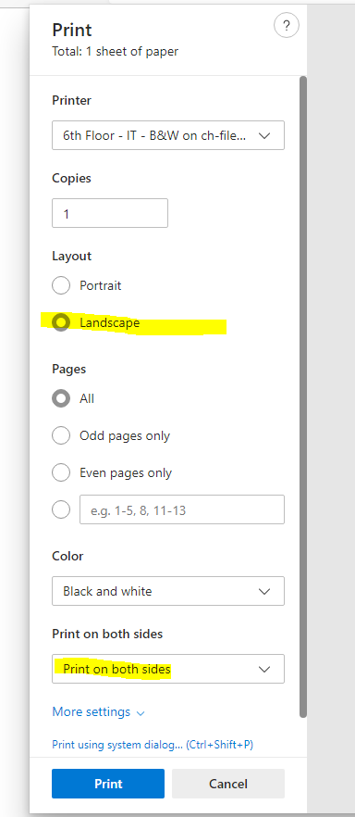

- Document will print out, save for records exit out of print screen

