- Make sure all displays are turned on.
  - For Council Chambers, connect to HDMI at middle table and turn all TV’s on.
  - For Council Hearing Room, connect to HDMI at middle table, turn all TV’s on, and ensure HDMI splitter at the back is turned on.
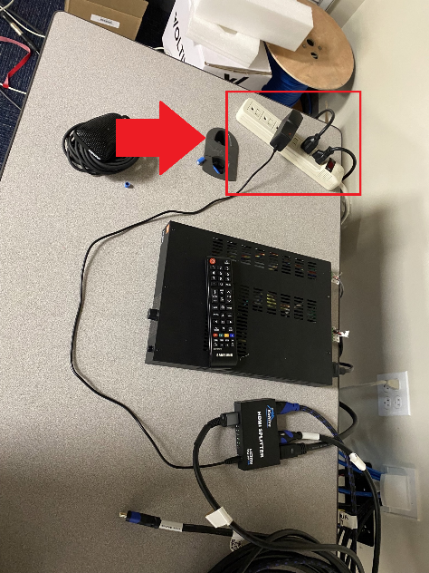
- Set display to Extend mode by pressing the windows button and P ( + P) and select “Extend”.
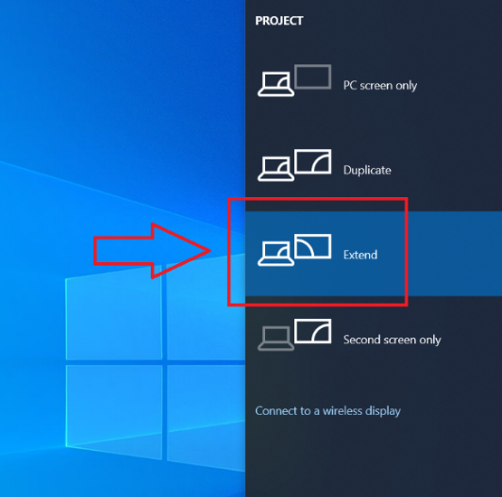
- In Powerpoint, open the presentation and go to the “Slideshow” tab.
- Under “Monitor” select either “HDMI Splitter” (Chambers) or “SAMSUNG” (Hearing Room).
- Ensure “Use Presenter View” is checked
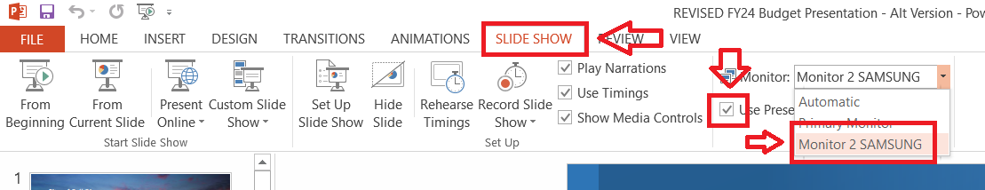
- Start presentation

